Similar packaging Rexulti® (brexpiprazole)

Look-Alike Medicines | Product 1 | Product 2
Photo | 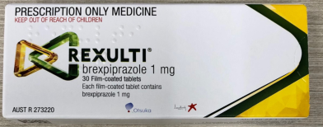 | 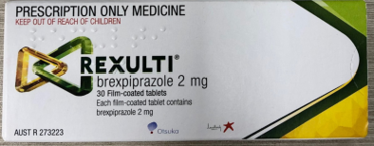
Name | brexpiprazole | brexpiprazole
Strength | 1 mg | 2 mg
Formulation | Tablet | Tablet
Manufacturer | Lundbeck Australia Pty Ltd | Lundbeck Australia Pty Ltd
Brand Name | Rexulti® | Rexulti®
Other comments | 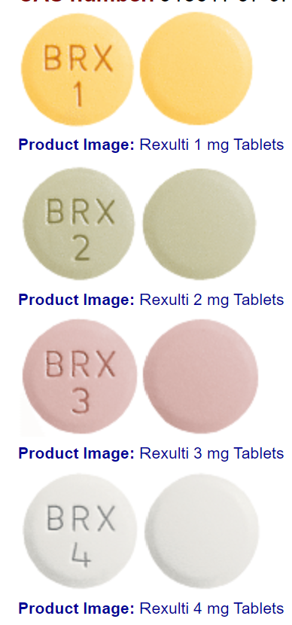  - No other generic brand available  - Usual dose (AMH): Oral, initially 1 mg once daily on days 1–4, then increase to 2 mg once daily on days 5–7, then to 4 mg once daily from day 8, depending on response. Usual maintenance dose 2–4 mg once daily. Use half the usual dose in CYP2D6 poor metabolisers.

Date reported to NSW TAG | 10/9/2021
Background to alert | Email from member: One of our pharmacy technicians drew this to my attention recently. These two products have very similar packaging. The box ends used to have larger numbers preceding the strength but now they are a smaller font and look virtually identical on quick glance.
Actual outcome/s | No incident occurred (that is, incident averted)
Risk management strategies | For NSW TAG:  ☐ Alert company: Telephone Aus: 1800 025 554, Email: SafetyLuAustralia@lundbeck.com  ☐ Raise awareness with members via email, at meetings, post to SHPA discussion forum?  For hospitals:  ☐ No alternate brands currently available anywhere for this medicine  ☐ Review where medicine is stored and assess if both strengths required where it is stored. If both required, separate the 2 strengths on the shelves or consider making one strength available by dispensing to individual patient only.  ☐ ?+/- shelf signage?  ☐ The packaging of the 3 mg and 4 mg strengths stocked are similar but not as much as 1mg and 2mg strengths.  ☐ Can the 2 mg be kept only and tablet halved when a 1 mg dose is required? (1 mg appears to only required for a short period during initiation of the medicine)  ☐ Automation: use barcode scanning of medicines as part of dispensing process…  ☐ Stickers on the boxes to warn packaging look-alike?

